

TRIBHUVAN UNIVERSITY
Faculty of Science and Technology Vedas College
Jawlakhel, Lalitpur

A Project Report On
Online Job Portal System

Submitted To:
Department of Science and Technology Vedas College

Submitted By: Anil Maharjan Prajwal Chaulagain Bibek Dulal
Saugat Khadka



TRIBHUVAN UNIVERSITY
Faculty of Science and Technology Vedas College

DECLARATION

We hereby declare that the work presented in this project has been done by ourselves and has not been submitted elsewhere for the award of any degree. All sources of information have been specifically acknowledged by reference to the author(s) or institution(s).

Submitted By:
Anil Maharjan
Prajwal Chaulagain Bibek Dulal
Saugat Khadka



TRIBHUVAN UNIVERSITY
Faculty of Science and Technology Vedas College

LETTER OF APPROVAL
This is to certify that the project entitled Online Job Portal System, submitted by Anil Maharjan, Prajwal Chaulagain, Bibek Dulal, and Saugat Khadka, in partial fulfillment of the requirements for the degree of Bachelor of Science in Computer Science and Information Technology (BSc CSIT), has been thoroughly studied and evaluated.

....................................  SIGNATURE OF SUPERVISOR  Mr. Santosh Rauniyar Department of Science and Technology  Vedas college | ....................................  SIGNATURE OF HOD  Mr. Harendra Raj Bista Department of Science and Technology  Vedas college
....................................  SIGNATURE INTERNAL EXAMINER  Mr. Suvash Khadka  Vedas college | ....................................  SIGNATURE INTERNAL EXAMINER



TRIBHUVAN UNIVERSITY
Faculty of Science and Technology Vedas College

SUPERVISOR’S RECOMMENDATION
I hereby recommend that the project entitled Online Job Portal System, carried out under my suprevision by Anil Maharjan, Prawjal Chaulagain, Bibek Dulal, and Saugat Khadka, in partial fulfillment of the requirements for the degree of Bachelor of Science in Computer Science and Information Technology (BSc CSIT), be accepted and processed for evaluation.
To the best of my knowledge, this project is an original work of the students and meets the academic standards required by Tribhuvan University, Faculty of Science and Technology.

SIGNATURE
Santosh Rauniyar Supervisor
Vedas College
Department of science and technology

ACKNOWLEDGMENT
We would like to express our heartfelt gratitude to our respected supervisor, for his invaluable guidance, encouragement, and continuous support throughout the development of our project, “Online Job Portal System”. His expertise and constructive feedback have been instrumental in shaping our work.
We extend our sincere appreciation to our institution and faculty members for providing us with the necessary resources and a conducive learning environment. Their insights and knowledge have greatly enriched our understanding of System Analysis and Design.
Lastly, we acknowledge the collective efforts of our team members Anil Maharjan, Prajwal Chaulagain, Bibek Dulal, and Saugat Khadka for their dedication, hard work, and collaboration in successfully completing this project. Their cooperation and commitment played a vital role in bringing this project to fruition.
Thank you all for your support and guidance.

Sincerely, Anil Maharjan Prajwal Chaulagain
Bibek Dulal Saugat Khadka

ABSTRACT
The Online Job Portal System is a comprehensive web-based application developed to modernize and streamline the recruitment process through digital transformation. The system addresses key challenges in traditional job searching and hiring by providing a centralized platform for managing job listings, candidate applications, employer profiles, and recruitment workflows. Built using modern web technologies, the application delivers a secure, role-based interface that enables efficient interaction between job seekers, employers, and system administrators.
The system incorporates essential features such as real-time job search and filtering, online application submission, resume management, employer-based job posting, and dynamic application tracking. It implements a secure authentication mechanism with role-based access control, ensuring that system functionalities and sensitive data are accessible only to authorized users. The responsive and user-friendly interface enhances accessibility across multiple devices, supporting seamless user experience in diverse working environments.
This project addresses the increasing demand for digital recruitment solutions by replacing manual and fragmented hiring processes with an integrated system that improves efficiency, accuracy, and communication. The report presents a detailed overview of the system development lifecycle, including system analysis, design modeling, implementation strategies, and testing procedures. It highlights the challenges encountered during development and the solutions adopted to ensure system reliability, data integrity, and performance optimization.
The modular design of the system allows for future enhancements such as integration with mobile applications, artificial intelligence-based job recommendations, automated notifications, and third-party service integration. The report concludes by evaluating the system’s effectiveness in improving recruitment efficiency, enhancing user experience, and supporting modern employment practices in a digital environment.
Keywords: Online Job Portal System, Recruitment Management, Job Search Platform, Resume Management, Employer Dashboard, Role-Based Access Control, Web Application, System Analysis and Design, Digital Recruitment, Database Management

LIST OF ABBREVIATIONS

ACID | Atomicity, Consistency, Isolation, Durability
AI | Artificial Intelligence
CRUD | Create, Read, Update, Delete
CSS | Cascading Style Sheets
DFD | Data Flow Diagram
ERD | Entity-Relationship Diagram
FK | Foreign Key
HTML | HyperText Markup Language
IDE | Integrated Development Environment
MySQL | My Structured Query Language
PK | Primary Key
PHP | Hypertext Preprocessor
SDLC | System Development Life Cycle
SQL | Structued Query Language
UML | Unified Modeling Language
VPS | Virtual Private Server
XAMPP | Cross-Platform, Apache, MySQL, PHP, Perl

LIST OF FIGURES

Table of Figures
Figure 1:Gantt Chart 7
Figure 2:Waterfall Model 8
Figure 3:Level-0 DFD 10
Figure 4:Level-1 DFD 11
Figure 5:Level-2 DFD 12
Figure 6:ER-Diagram 14
Figure 7:Use-Case Diagram 16
Figure 8:Class Diagram 18
Figure 9:Sequence Diagram 19
Figure 10:User Dashboard 36
Figure 11:User Profile 36

Table of Contents
Table of Contents
DECLARATION i
LETTER OF APPROVAL ii
SUPERVISOR’S RECOMMENDATION iii
ACKNOWLEDGMENT iv
ABSTRACT v
LIST OF ABBREVIATIONS vi
LIST OF FIGURES vii
Chapter 1: Introduction 1
  - Overview 1
  - Organization Profile 1
  - Group Information 1
  - Background of the Project 2
  - Beneficiaries of the System 3
  - Literature Review 3
Chapter 2: Planning 4
  - Mapping of Stakeholders 4
  - Projection Identification and selection 5
    - Project Identification 5
    - Project Selection 5
  - Feasibility Study 5
    - Technical Feasibility 6
    - Economic Feasibility 6
    - Operational Feasibility 6
    - Schedule Feasibility 6
    - Legal Feasibility 7
  - Methodology 7
Chapter 3: System Analysis 9
  - Information Gathering 9
  - Modeling 9
    - Data Flow Diagram 10
    - ER Diagram 13
    - Decision Table 15
    - Use Case Diagram 16
    - Class Diagram 17
    - Sequence Diagram 19
Chapter 4: System Design 20
  - Designing Forms and Reports 20
  - Logical Database Design 21
  - Physical Database Design 22
  - Designing the Human Interface 23
Chapter 5: Implementation 24
  - Coding 24
  - Testing 26
  - Installation 28
  - Documentation 29
  - Training 29
    - User Training: 29
    - Admin Training: 29
  - Support and Maintenance 30
Chapter 6: Conclusion and Recommendation 31
  - Conclusion 31
  - Recommendations 31
References 33
Annex 34
- Survey Questionnaires 34
- System Screenshots 36
- Sample Code 37

Chapter 1: Introduction

Overview
The rapid development and growth of information technology have completely changed and revolutionized the recruitment industry by transforming traditional methods of job search and recruitment. The Online Job Portal System is an online system designed to fill the gap between job seekers and organizations by making the entire recruitment process easy and efficient while at the same time saving time, cost, and effort. The Online Job Portal System project involves the analysis and design of a centralized system for job seekers to register and apply for jobs, and for organizations to post jobs and manage applications. The main objective of the Online Job Portal System project is to apply the principles learned in system analysis and design in creating an efficient and practical system to tackle real-world problems. The system analysis and design process includes planning, feasibility study, modeling, and designing to make the system easily accessible to job seekers and to improve communication between organizations and candidates while making the recruitment process efficient. This report includes a comprehensive study on the System Development Life Cycle (SDLC) for the proposed Online Job Portal System.

Organization Profile
Tribhuvan University (TU) is the oldest and largest university in Nepal, established in 1959. It operates under the Faculty of Science and Technology, offering various academic programs including the Bachelor of Science in Computer Science and Information Technology (BSc CSIT).
Vedas College, affiliated with Tribhuvan University, is dedicated to providing quality education in science and technology. The institution focuses on developing practical knowledge and technical skills among students, preparing them for professional careers in the IT field.

Group Information
This project is carried out as a group assignment by BSc CSIT students as a part of academic requirement.

Project Title: Online Job Portal System Institution: Vedas College, Jawlakhel, Lalitpur

Department: Science and Technology Program: BSc.CSIT, 5th Semester Academic Year: 2025-2026

Team Members:
Anil Maharjan Prajwal Chaulagain Bibek Dulal
Saugat Khadka

Supervisor: Mr. Santosh Rauniyar, Department of Science and Technology, Vedas College
Internal Examiner: Mr. Suvash Khadka, Vedas College
HOD: Mr. Harendra Raj Bista, Department of Science and Technology, Vedas College

Background of the Project
In the modern fast-paced and competitive world, the process of recruitment has become more complex. The traditional methods of recruitment, such as advertising in newspapers, filling out applications, and maintaining records manually, are time- consuming and inefficient. This makes it difficult for both the candidates and the organizations to find the right candidates. With the advent of information and communication technology, the process of recruitment has changed to online platforms. These platforms are efficient in the process of recruitment and provide a common platform for both organizations and candidates. The Online Job Portal System provides an efficient solution to the traditional methods of recruitment. It provides a better alternative to traditional methods by making the process faster and more accurate. The Online Job Portal System provides a platform for both organizations and candidates. The candidates can search for jobs and apply online, while organizations can post their job vacancies. Overall, the Online Job Portal System provides an efficient solution to the traditional methods by making the process faster and more accurate.

Beneficiaries of the System
The Online Job Portal System provides benefits to various stakeholders involved in the recruitment process. The major beneficiaries of the system are as follows:

Job Seekers:
Job seekers benefit by gaining easy access to a wide range of job opportunities in one centralized platform. They can create profiles, upload resumes, and apply for jobs quickly, saving time and effort compared to traditional methods.

Employers/Recruiters:
Employers can efficiently post job vacancies and reach a large pool of potential candidates. The system helps in managing applications, shortlisting candidates, and reducing the time and cost involved in the recruitment process.

Administrators:
Administrators benefit from having centralized control over the system. They can monitor activities, manage users, ensure data integrity, and maintain smooth system operations.

Organizations/Companies:
Companies can improve their hiring efficiency and find suitable candidates faster. This leads to better workforce management and productivity.

Society:
The system contributes to reducing unemployment by connecting job seekers with relevant opportunities. It promotes transparency and accessibility in the job market.
Overall, the system enhances the recruitment ecosystem by providing an efficient, reliable, and accessible platform for all users involved.

Literature Review
The development of online job portals has been driven by the rapid growth of internet technology and the increasing need for efficient recruitment solutions. Numerous studies highlight how digital platforms have simplified the hiring process for both job seekers and employers. Traditional recruitment methods, such as newspaper advertisements and manual applications, are widely criticized in the literature for being slow, inefficient, and limited in reach. These shortcomings have led to the rise of online recruitment systems, which significantly reduce hiring time and allow organizations to access a much larger pool of candidates. Existing platforms like LinkedIn and Indeed have proven the effectiveness of web-based job portals. Research shows that they improve communication between employers and job seekers while increasing transparency in the recruitment process. Studies on

usability emphasize the importance of user-friendly interfaces, efficient search functions, and real-time updates. It is observed that more accessible and easy-to-use systems attract a larger number of users. However, literature also points out several limitations of current platforms, including complexity, high costs for full features, and lack of regional customization. This highlights the need for simpler, affordable, and locally focused job portal systems.

Chapter 2: Planning

Mapping of Stakeholders
Stakeholder mapping is an essential part of system planning as it identifies all individuals or groups who are affected by or have an interest in the Online Job Portal System. It helps in understanding their roles, responsibilities, and level of involvement in the system.
The key stakeholders of the system are mapped as follows:

Job Seekers (Primary Stakeholders):
They are the main users of the system who search and apply for jobs. Their primary interest is finding relevant job opportunities easily and efficiently.

Employers/Recruiters (Primary Stakeholders):
These stakeholders use the system to post job vacancies and recruit suitable candidates. They require efficient tools for managing applications and selecting candidates.

System Administrators (Key Stakeholders):
Administrators are responsible for managing and maintaining the system. They ensure smooth operation, handle user management, and monitor system activities.

Organizations/Companies (Secondary Stakeholders):
Companies benefit from improved recruitment processes and efficient hiring. They rely on the system for accessing a wider pool of candidates.

Developers (Technical Stakeholders):
Developers are responsible for designing, developing, and maintaining the system. They ensure that the system meets functional and non-functional requirements.

Government/Regulatory Bodies (External Stakeholders):
These stakeholders may influence the system through rules and regulations related to employment, data protection, and online services.

Projection Identification and selection
Project identification and selection are important steps in the system development process, where a suitable project is chosen based on organizational needs, feasibility, and expected benefits. This step ensures that the selected project is practical, valuable, and aligned with user requirements.

Project Identification

The Online Job Portal System was identified as a potential project due to the increasing demand for efficient and accessible recruitment solutions. The traditional methods of job searching and hiring were observed to be time-consuming, inefficient, and limited in reach. Additionally, existing online systems often present challenges such as complexity, lack of customization, and limited accessibility for certain users.
The need for a centralized platform that simplifies the interaction between job seekers and employers led to the identification of this project. The system aims to address real-world problems by providing a structured and automated approach to recruitment.

Project Selection

The selection of the Online Job Portal System was based on several key factors:

      - Feasibility: The project is technically feasible using available tools and technologies such as web development frameworks and database systems.
      - Relevance: The system addresses a common and practical problem faced by both job seekers and employers.
      - Scope: The project has a well-defined scope that can be completed within the given time and resources.
      - User Demand: There is a high demand for efficient recruitment platforms in the current job market.
      - Learning Value: The project provides a good opportunity to apply concepts of system analysis and design, including requirement analysis, database design, and system modeling.

Feasibility Study
The feasibility study evaluates whether the Online Job Portal System can be successfully developed and implemented. The key feasibility aspects are described below:

Technical Feasibility
      - The system can be developed using existing web technologies (e.g., frontend, backend, and database tools)
      - Required hardware and software resources are readily available
      - Developers have sufficient technical knowledge and skills
      - No major technical risks or limitations are identified

Economic Feasibility
      - Development cost is low to moderate
      - Use of open-source tools reduces expenses
      - Reduces manual work and operational costs
      - Provides long-term benefits compared to initial investment

Operational Feasibility
      - System is easy to use and user-friendly
      - Requires minimal training for users
      - Improves efficiency in job searching and recruitment
      - Acceptable and beneficial for all stakeholders

Schedule Feasibility
      - Project can be completed within the given time frame
      - Development phases are well-defined and manageable
      - Proper scheduling ensures timely delivery
      - No major delays are expected

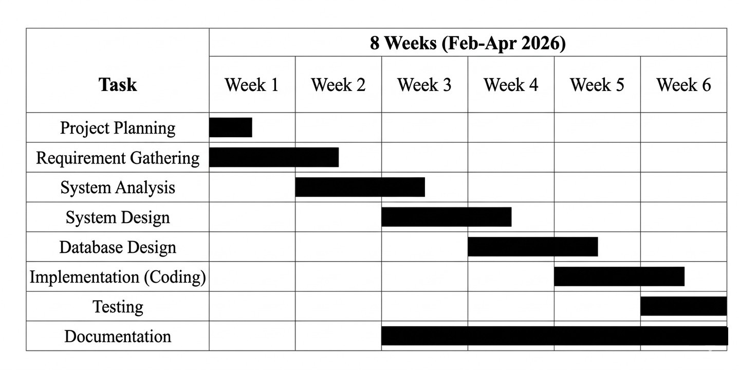
Figure 1:Gantt Chart

Legal Feasibility
      - Complies with data protection and privacy regulations
      - Ensures secure handling of user information
      - No violation of legal or regulatory requirements
      - Safe and lawful operation of the system

Overall, the feasibility study confirms that the proposed system is practical, cost- effective, and achievable within the given constraints.

Methodology
The development of the Online Job Portal System follows the Waterfall Model, which is a linear and sequential approach to system development. This model was chosen because of its simplicity, structured nature, and suitability for projects with clearly defined requirements. In this approach, each phase is completed before moving on to the next, ensuring proper planning and documentation throughout the development process.
The first phase, Requirement Analysis, involved gathering system requirements by studying existing job portals and identifying the needs of job seekers, employers, and administrators. This was followed by the System Design phase, where diagrams such as DFDs and ER diagrams were created along with database structure and interface design to provide a clear blueprint for the system.

In the Implementation phase, the system was developed using technologies like HTML, CSS, JavaScript, PHP, and MySQL. After development, the system underwent Testing, including unit and system testing, to identify and fix errors. Once testing was complete, the system was deployed on a local server using XAMPP.
Finally, the system enters the Maintenance phase, where updates, bug fixes, and improvements are made to ensure smooth performance and reliability. The use of the Waterfall Model helped in developing a well-organized and efficient Online Job Portal System.

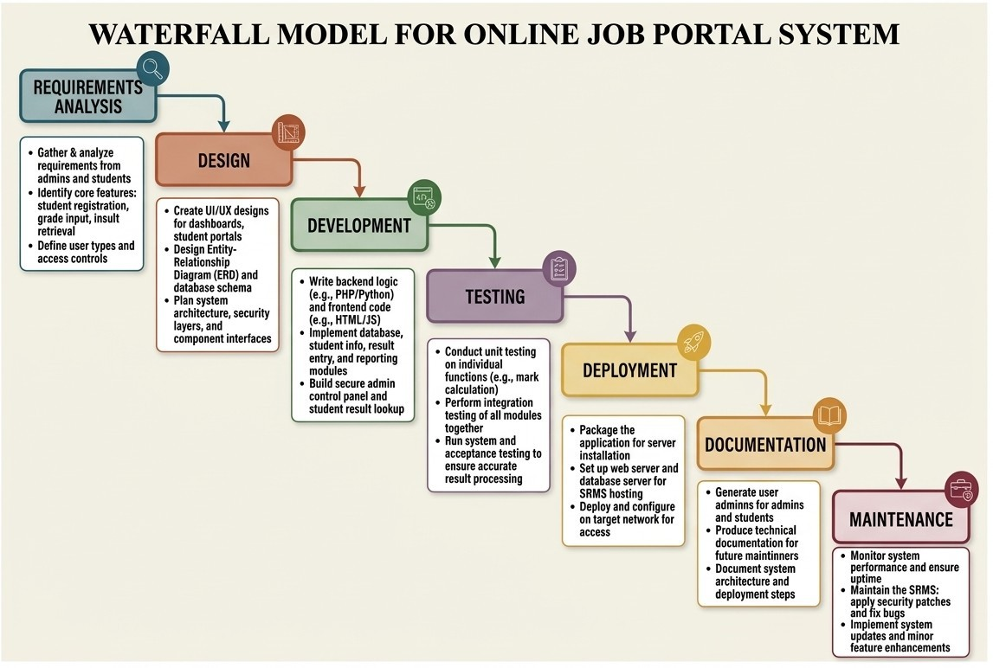
Figure 2:Waterfall Model

Chapter 3: System Analysis

Information Gathering
Information gathering is a crucial step in system analysis, as it involves collecting relevant data to understand the requirements, expectations, and challenges associated with the proposed Online Job Portal System. This process ensures that the system is designed to meet the actual needs of its users and stakeholders.

Methods Used:

- Surveys and Questionnaires:
  - Distributed among students, fresh graduates, and working professionals to understand their challenges in searching for jobs.
  - Collected data on preferred features such as resume upload, job alerts, and application tracking.

Interviews:
  - Conducted with HR personnel and recruiters to understand the employer’s perspective.
  - Identified requirements for posting jobs, filtering candidates, and managing applications.

Observation:
  - Studied existing job portals to identify standard features, user interface design, and common issues.
  - Observed how job seekers search for jobs and how employers manage applications online.

Literature Review:
  - Consulted research articles and case studies on online recruitment systems.
  - Gathered insights on best practices, security concerns, and database requirements.

The collected information was carefully analyzed and documented to define system requirements, identify key functionalities, and ensure that the proposed system is efficient, user-friendly, and capable of addressing real-world recruitment challenges.

Modeling
Modeling is an essential part of system analysis that provides a visual representation of the system’s structure, processes, and data flow. It helps in understanding how the

system operates and how different components interact with each other. For the Online Job Portal System, various modeling tools such as Data Flow Diagrams (DFD), Entity-Relationship (ER) Diagrams, and Decision Trees/Tables are used to represent system functionality and data relationships.

Data Flow Diagram
A Data Flow Diagram (DFD) is used to illustrate the flow of data within the system. It shows how data moves from input to processing and finally to output. The DFD helps in understanding system processes, data storage, and interactions between different entities.
Context Diagram (Level 0)
The Level 0 DFD represents the Online Job Portal System as a single system process interacting with three external entities:
      - Job Seeker: Provides registration and login details, searches for jobs, and submits job applications; receives job listings and application status.
      - Employer: Provides job postings and company details; receives applications from job seekers and views applicant information.
      - Admin: Provides login credentials and manages users, job postings, and system data; receives system reports and maintains overall system control.

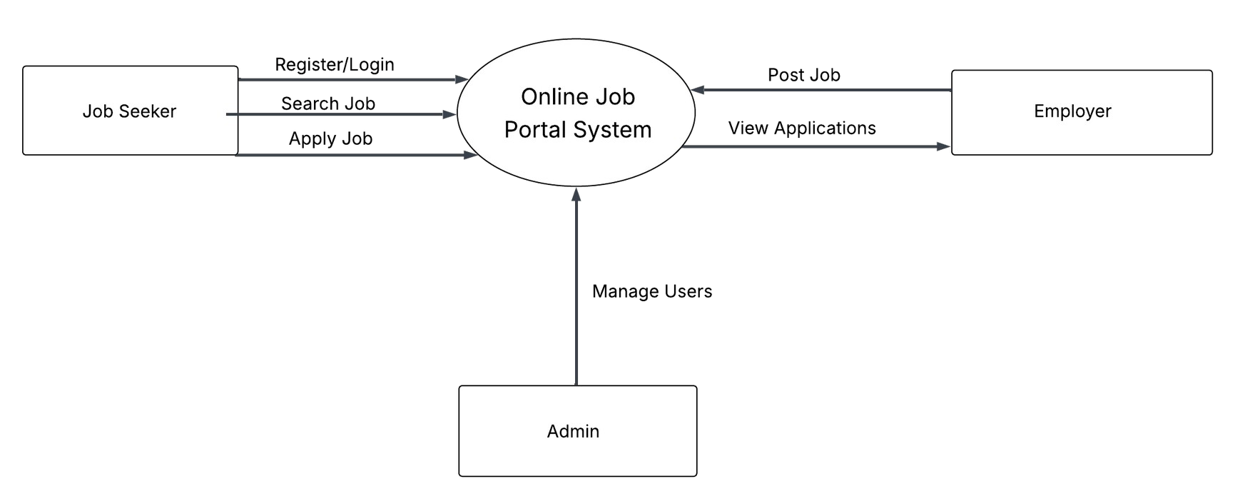
Figure 3:Level-0 DFD

Level-1 DFD
At Level 1, the Online Job Portal System is decomposed into four primary processes. Process 1.0, User Authentication, receives registration and login details from Job Seekers and Employers and stores or verifies data in the User Database. Process 2.0, Job Management, allows Employers to post and manage job listings, which are stored in the Job Database and made available to Job Seekers. Process 3.0, Application Processing, handles job applications submitted by Job Seekers and stores them in the Application Database for Employers to review. Process 4.0, Profile Management, manages user profile information, allowing users to update their details, which are stored in the User Database and accessed when needed.

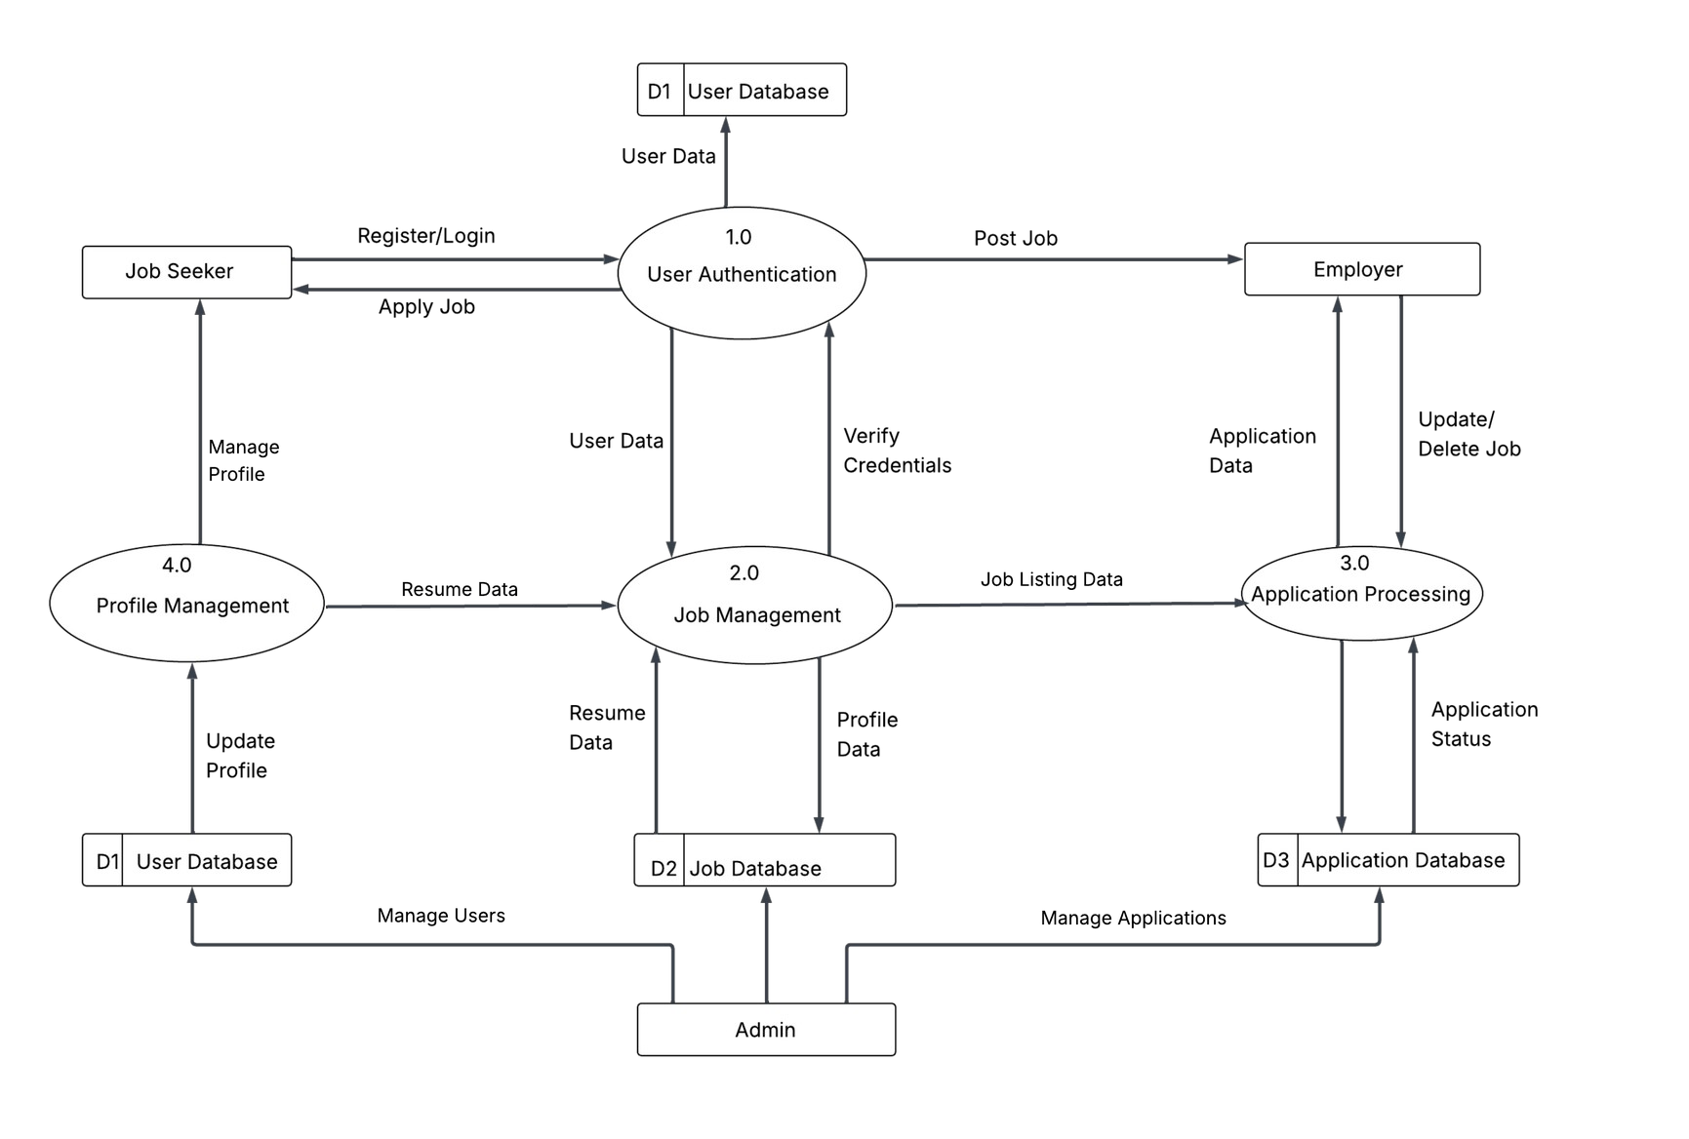
Figure 4:Level-1 DFD

Level-2 DFD
Process 3.0 (Application Processing) is further decomposed into four sub-processes: Process 3.1 (Check User Profile) where the system verifies the job seeker’s profile details from the User Database; Process 3.2 (Upload Resume) where the job seeker uploads their resume and related documents; Process 3.3 (Submit Application) where the job seeker submits the application for a selected job; and Process 3.4 (Store Application) where the application details are saved in the Application Database and made available for employer review.

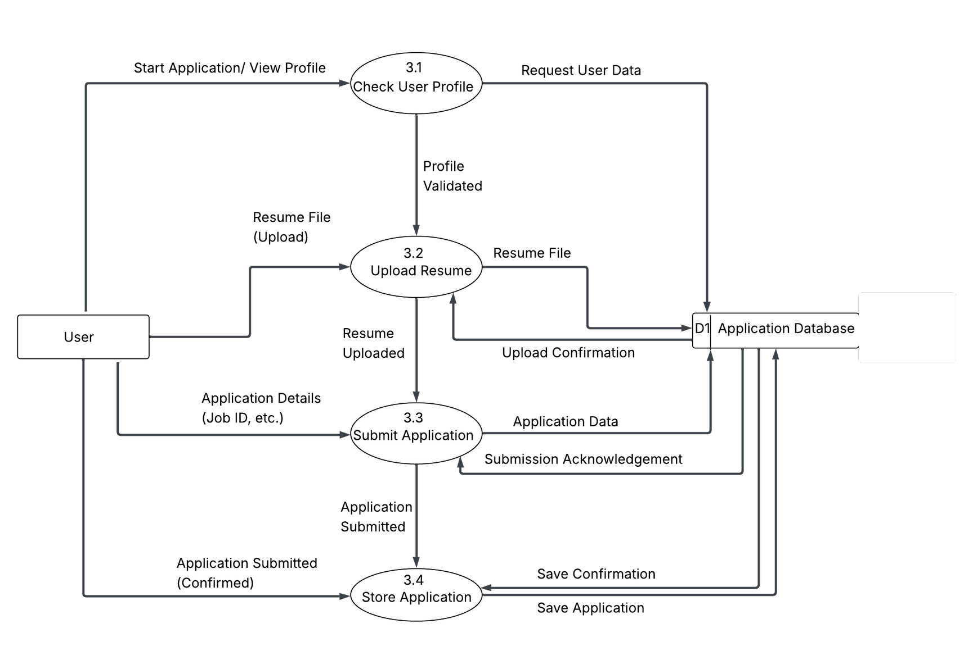
Figure 5:Level-2 DFD

ER Diagram
An entity-relationship diagram (ERD) is a model that shows the logical relationships and interaction among system entities. An ERD provides an overall view of the system and serves as a blueprint for designing the database structure. The following represents the logical data model of the proposed Online Job Portal System.
Entities:
      - User: Attributes - user_id (PK), name, email, password, role. Represents both job seekers and employers using the system.
      - Company: Attributes - company_id (PK), name, location. Stores company details that post job vacancies.
      - Job: Attributes - job_id (PK), title, description, salary, company_id (FK). Represents job postings created by companies.
      - Application: Attributes - application_id (PK), user_id (FK), job_id (FK), status. Stores job applications submitted by users.

Relationships:
      - User to Job: Many-to-Many - a user can apply to multiple jobs and a job can have multiple applicants; this relationship is handled through the Application entity.
      - Company to Job: One-to-Many - one company can post multiple jobs, while each job belongs to one company.
      - User to Application: One-to-Many - one user can have multiple applications.
      - Job to Application: One-to-Many - one job can receive multiple applications.

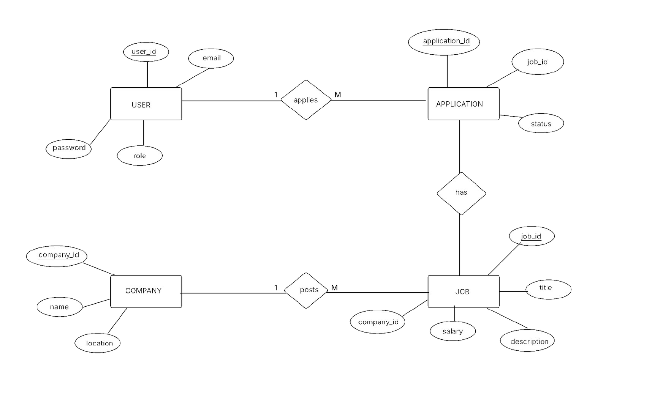
Figure 6: ER-Diagram

Decision Table
A decision table is a tabular representation of decision logic that shows different conditions and the corresponding actions to be taken. It is used to simplify complex decision-making by organizing all possible combinations of conditions and their outcomes in a structured format. Each row represents a condition or action, and each column represents a rule.
The following decision table defines system responses for the user login and job application process:

Logic Decision Table

Conditions | Rule 1 | Rule 2 | Rule 3 | Rule 4
User Registered? | Yes | Yes | No | No
Password Correct? | Yes | No
Actions
Allow Login | ✓ | x | x | x
Show Error Message | x | ✓ | ✓ | ✓

Job Application Table

Conditions | R1 | R2 | R3 | R4
User Logged In | Y | Y | N | N
Profile Complete | Y | N
Resume Uploaded | Y | N
Actions
Allow Apply | ✓ | x | x | x
Ask Login | x |  | ✓ | ✓
Complete Profile | x | ✓ | x | x
Upload Resume | x | ✓ | x | x

Use Case Diagram
A use case diagram is a visual representation used in system design to show the interaction between users (called actors) and a system. It illustrates the different functionalities (use cases) that the system provides and how external entities interact with those functions.
This Use Case Diagram illustrates the interactions within an Online Job Portal System, depicting three main user roles: Job Seeker, Employer, and Administrator. Job Seekers can register and log in, search for jobs, apply for jobs, upload resumes, and manage their profiles. Employers are responsible for posting job vacancies, viewing applications, and managing job listings. Administrators manage the overall system functions, including user management, job moderation, and maintaining system data, with implied dependencies between use cases such as "Apply for Job" and "Search Job," as well as "Post Job" and "View Applications."

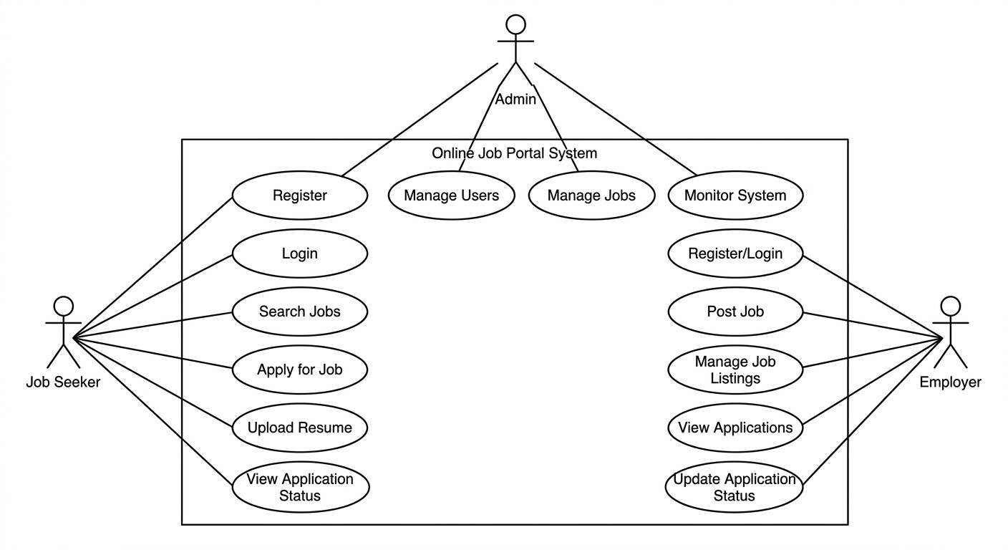
Figure 7:Use-Case Diagram

Class Diagram
A class diagram is a type of Unified Modeling Language (UML) diagram that represents the structure of a system by showing its classes, attributes, methods, and the relationships between them. It provides a static view of the system and helps in designing the object-oriented structure of the application.
This class diagram represents an Online Job Portal System with five main classes: User, Admin, Company, Job, and Application. The User class includes attributes like user_id, name, email, password, and role, with methods such as register(), login(), and applyJob(). The Admin class manages the system with attributes admin_id, username, and password, and methods like manageUsers() and manageJobs().
The Company class stores company details and posts jobs, while the Job class contains job information. The Application class represents job applications with attributes like application_id and status. Relationships show that one User can have many Applications, one Job can have many Applications, and one Company can post many Jobs. The Admin is associated with managing users and jobs.

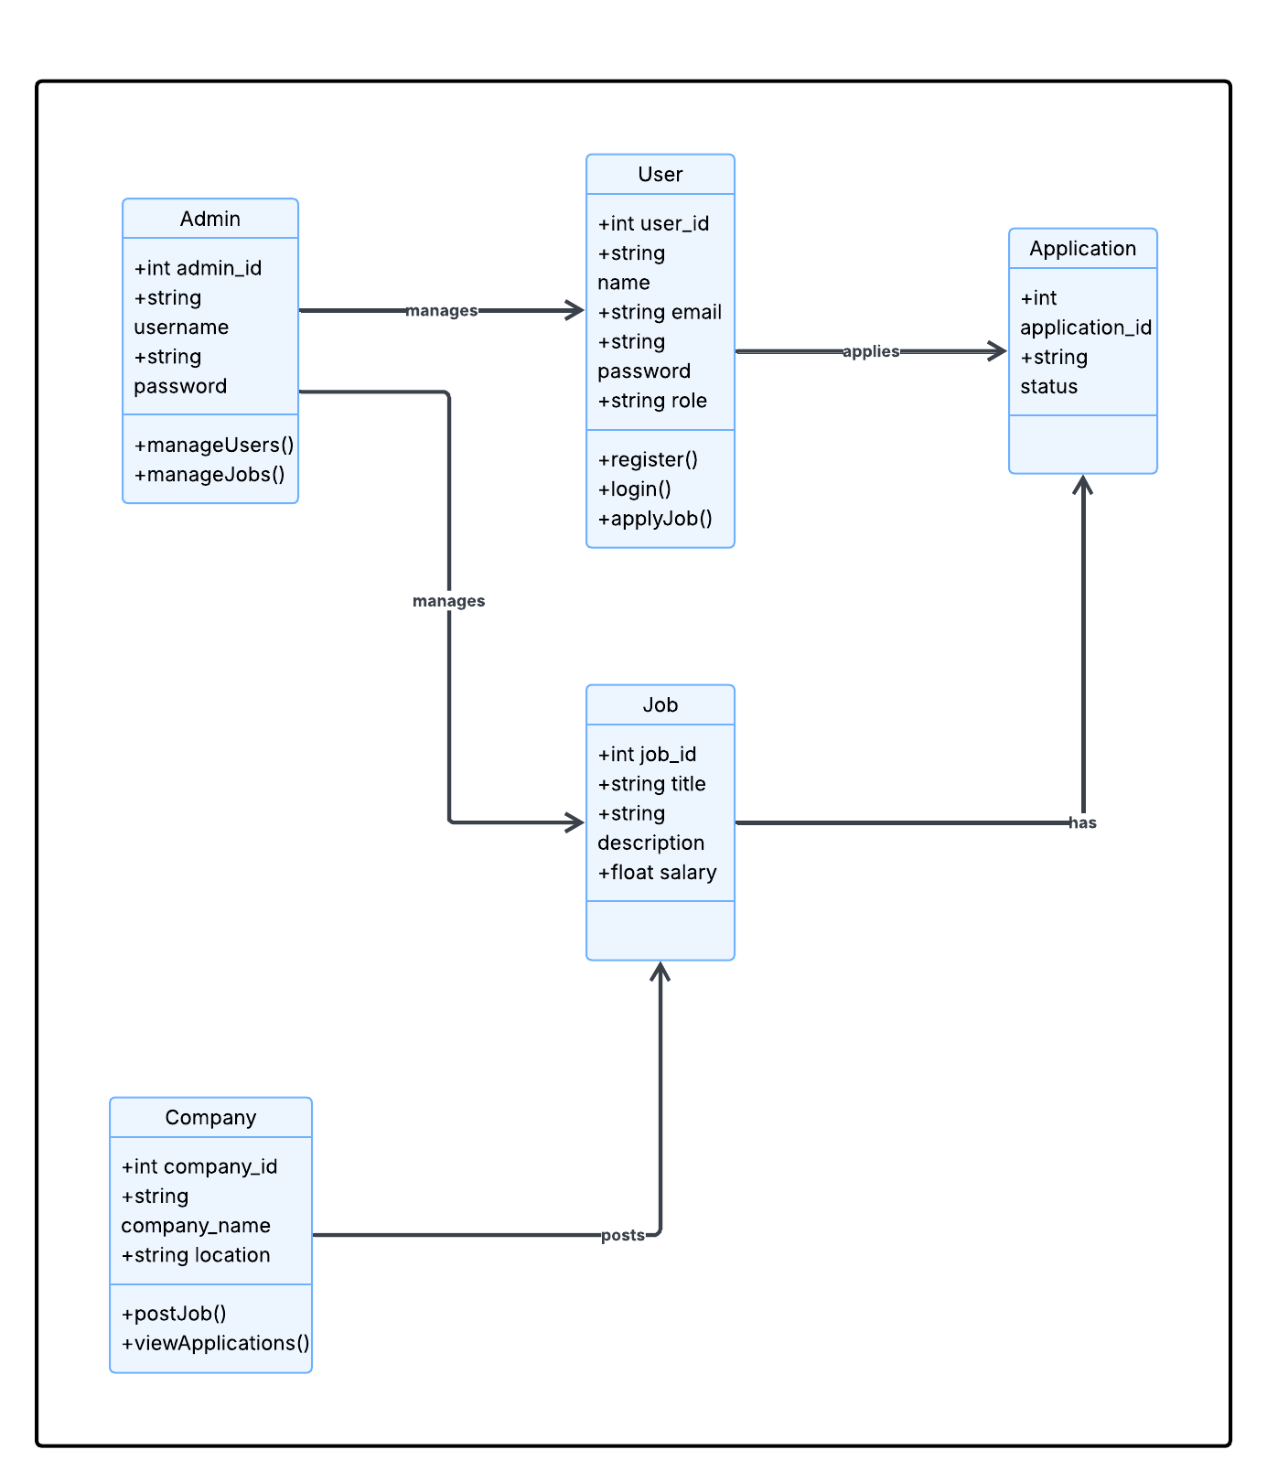
Figure 8:Class Diagram

Sequence Diagram
This sequence diagram illustrates the interaction between the Job Seeker, Web Interface, Application Server, and Database in the Online Job Portal System during the job application process. The Job Seeker initiates the process by searching for jobs through the web interface. The request is sent to the application server, which retrieves job data from the database and displays the available jobs to the user.
When the Job Seeker applies for a job, the application details are sent from the web interface to the server, which then stores the information in the database. After successful storage, a confirmation is sent back through the server to the web interface, and the user is notified that the application has been successfully submitted. The diagram clearly shows the step-by-step flow of interactions involved in searching and applying for a job.

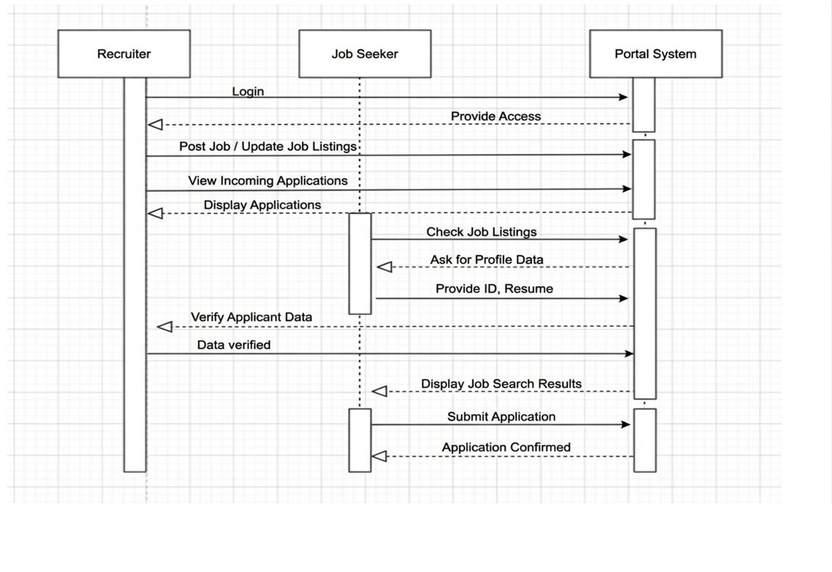
Figure 9:Sequence Diagram

Chapter 4: System Design

Designing Forms and Reports
The Online Job Portal System includes following key input forms and reports:

Input Forms:
    - User Registration Form: This form allows new users (job seekers and employers) to create an account by entering details such as name, email, password, and role.
    - Login Form: This form is used by registered users to access the system securely using their credentials.
    - User Profile Form: Job seekers can update their personal information, skills, education, and experience, while employers can update company details.
    - Job Posting Form: Employers use this form to create and publish job vacancies by entering job title, description, requirements, salary, and location.
    - Job Application Form: Job seekers use this form to apply for jobs by submitting their resume and required details.
    - Search Form: This form allows users to search for jobs based on criteria such as job title, location, and category.
    - Admin Management Form: Admin uses this form to manage users, approve job postings, and monitor system activities.

Output Reports:
    - Job Listings Report: Displays available job vacancies with details such as company, position, and requirements.
    - Application Status Report: Allows job seekers to track the status of their job applications (e.g., pending, accepted, rejected).
    - Employer Job Report: Provides employers with a list of jobs they have posted along with application statistics.
    - Applicant Report: Shows details of candidates who have applied for a specific job.
    - User Activity Report: Helps the admin monitor system usage, including registrations and login activities.
    - System Summary Report: Provides an overview of total users, jobs posted, and applications submitted within the system.

Logical Database Design
The logical database design defines the relational schema of the Job Portal System. The database is named “job-portal” and comprises tables:

Table: Admin Table

Column Name | Data Type | Constraint | Description
username | VARCHAR(50) | PRIMARY KEY, NOT NULL | Admin username
password | VARCHAR(50) | NOT NULL | Admin login password

Table: User Table

Column Name | Data Type | Constraint | Description
user_id | INT | PRIMARY KEY, NOT NULL | Unique user identifier
name | VARCHAR(50) | NOT NULL | User’s full name
email | VARCHAR(50) | UNIQUE, NOT NULL | User email address
password | VARCHAR(50) | NOT NULL | Login password
role | VARCHAR(50) | NOT NULL | User role (Job Seeker/Emplyer/Adm in)

Table: Company Table

Column Name | Data Type | Constraint | Description
company_id | INT | PRIMARY KEY, NOT NULL | Unique company identifier
company_name | VARCHAR(50) | NOT NULL | Name of the company
location | VARCHAR(50) | NOT NULL | Company location

Table: Job Table

Column Name | Data Type | Constraint | Description
job_id | INT | PRIMARY KEY, NOT NULL | Unique job identifier
title | VARCHAR(50) | NOT NULL | Job title
description | TEXT | NOT NULL | Job description
salary | VARCHAR(50) | NULL | Salary offered
company_id | INT | FOREIGN KEY, NOT NULL | References Company(company_i d)

Table: Application Table

Column Name | Data Type | Constraint | Description
application_id | INT | PRIMARY KEY, NOT NULL | Unique application ID
user_id | INT | FOREIGN KEY, NOT NULL | References User(user_id)
job_id | INT | FOREIGN KEY, NOT NULL | References Job(job_id)
status | VARCHAR(50) | NOT NULL | Application status (Pending/Accepted/R ejected)

Physical Database Design
The physical implementation of the Online Job Portal System database uses the following configuration:
    - Database Engine: MySQL 8.0 with InnoDB storage engine, ensuring ACID compliance and reliable transaction processing along with enforced foreign key constraints between tables.
    - Character Set: UTF-8 (utf8mb4), supporting a wide range of Unicode characters, allowing user names, company details, and job descriptions to be stored in multiple languages if required.
    - Indexes: Primary keys are automatically indexed for fast data retrieval. Additional indexes are applied on frequently searched fields such as email in the User table, company_name in the Company table, and title in the Job table to optimize search performance.

    - Server Environment: Apache 2.4 using XAMPP as the local development environment. The system can be deployed on a production server such as a cloud-based hosting service or a VPS with support for PHP and MySQL.
    - Backup: Regular database backups are recommended using phpMyAdmin in the form of .sql dump files. Backups should be performed periodically to prevent data loss, especially during high system usage or updates.
    - Security Measures: Passwords are stored in encrypted format, and access control mechanisms are implemented to restrict unauthorized access to sensitive data.
    - Normalization: The database is normalized up to an appropriate level to reduce redundancy and maintain data consistency across all tables.
This configuration ensures that the database system is efficient, secure, and capable of supporting the operational requirements of the Online Job Portal System.

Designing the Human Interface
The user interface of the Online Job Portal System was developed using HTML5, CSS3, and JavaScript, guided by the following design principles:
    - Visual Design: A clean and professional interface with a modern color scheme is used to enhance user experience. High-contrast text and well-structured layouts ensure readability across different devices and screen sizes.
    - Navigation: A user-friendly navigation bar is provided at the top of the interface, allowing easy access to key sections such as Home, Jobs, Profile, Dashboard, and Login. The admin panel includes a structured menu for managing users, jobs, and applications.
    - Form Usability: Forms are designed using proper labels, placeholders, and input validation techniques to guide users during data entry. Required fields are clearly marked, and logical grouping of inputs improves usability.
    - Feedback and Validation: The system provides immediate feedback through validation messages and alerts. Errors such as invalid login credentials or incomplete forms are displayed clearly, while successful actions (e.g., “Application submitted successfully”) are confirmed to the user.
    - User Experience: The interface is designed to be simple and intuitive for both job seekers and employers. Job seekers can easily search and apply for jobs, while employers can efficiently post jobs and manage applications.
    - Responsiveness: The system is responsive and compatible with desktops, tablets, and mobile devices, ensuring accessibility for users in different environments.

    - Search and Filtering: Advanced search options and filters are provided to help users quickly find relevant job listings based on criteria such as job title, location, and category.
This human interface design ensures that the system is easy to use, efficient, and accessible, providing a smooth and engaging experience for all users.

Chapter 5: Implementation

Coding
The Online Job Portal System was developed using the following stack:

Tech Stack:

Layer | Technology | Purpose
Frontend | HTML5, CSS3, JavaScript | User interface design and client-side validation
Backend | PHP 7.4+ | Server-side logic, session management, DB operations
Database | MySQL 8.0 | Structured data storage and retrieval
Server | Apache (XAMPP) | Local and production web server
IDE | Visual Studio Code | Code editing, debugging, and project management
DB Management | phpMyAdmin / MySQL Workbench | Database administration, schema design, and query execution
Version Control | Git / GitHub | Source code tracking and collaboration

Key modules implemented:

- Database Connection (db_connect.php): Establishes a MySQLi connection to the job_portal database on localhost. The connection object is included by all other PHP files using require_once, ensuring a single point of database configuration.
- Authentication Module (login.php / register.php): Validates submitted credentials for job seekers, employers, and admin users. On successful login,

sets a PHP session variable ($_SESSION['user']) and redirects users to their respective dashboards. On failure, displays a JavaScript alert indicating invalid credentials. Registration includes email uniqueness validation and password hashing for security.
- User Profile Management Module (profile.php / edit_profile.php): Allows users to view and update personal information. Input validation is performed using PHP and JavaScript (e.g., email format, required fields). Changes are updated in the database, and success or error feedback is provided via JavaScript alerts.
- Job Posting Module (post_job.php): Enables employers to create new job postings by submitting details such as job title, description, location, and salary. Input validation ensures all required fields are complete. Job data is stored in the Job table, and confirmation feedback is displayed upon successful insertion.
- Job Search & Application Module (search_jobs.php / apply_job.php): Job seekers can search for jobs using filters such as title, location, and category. Applying for a job inserts a record into the Application table with a status of “Pending.” The system prevents duplicate applications for the same job by the same user. Success and error messages are displayed via alerts.
- Application Management Module (view_applications.php): Employers can view applications submitted for their job postings, including applicant details and resumes. They can update application statuses to Accepted, Rejected, or Pending. Validation ensures correct status updates, with feedback provided in real-time.
- Admin Management Module (admin_dashboard.php): Allows the admin to manage users (job seekers and employers), approve job postings, and monitor system activities. Provides CRUD operations on all entities and ensures data integrity by validating entries before insertion or update.
- Notifications Module (optional): Sends email notifications to job seekers upon successful job application and to employers when a new application is submitted. Utilizes PHP’s mail() function or an SMTP library for automated messaging.

Testing
A multi-level testing strategy was applied to validate the correctness, reliability, and usability of the Online Job Portal System:
- Unit Testing:
Each module was tested individually with valid, invalid, and boundary inputs. For example:
  - Login Module: Tested with correct credentials, incorrect password, empty fields, and attempts at SQL injection.
  - Job Posting Module: Tested with valid and empty fields, excessively long titles, and invalid salary formats.
  - Job Application Module: Tested for duplicate applications, missing resume uploads, and invalid job IDs.

- Integration Testing:
Modules were tested in combination to ensure seamless data flow between components:
  - Jobs posted by an employer appear correctly in the job listings page.
  - Applications submitted by job seekers are accurately reflected in the employer’s dashboard.
  - User profile updates reflect correctly across the system.

- System Testing:
The complete end-to-end workflow was tested:
User registration → Login → Profile completion → Job search → Apply for job → Employer reviews applications → Update application status → Admin monitoring and management.
All functionalities were verified to ensure the system operates as intended under real-world usage scenarios.

- Boundary Testing:
The system was tested with edge case values to ensure stability:
  - User IDs and job IDs at minimum and maximum integer values.
  - Application attempts at boundary conditions (e.g., submitting the same job multiple times).
  - Large text fields for job descriptions and resumes to test storage and display limits.

Table Test Case And Result

Test Case | Input / Action | Expected Output | Actual Output | Status
Login with correct credentials | Valid email and password | User redirected to dashboard | User redirected to dashboard | ✔
Login with wrong password | Invalid password | Alert: Invalid Credentials | Alert shown | ✔
Login with empty password | Password field left blank | Alert: Password required | Alert shown | ✔
Post Job with missing title | Title field left blank | Alert: Job title required | Alert shown | ✔
Apply for same job twice | Job already applied by the user | Alert: Already Applied | Alert shown | ✔
Update user profile | Change phone number and skills | Data updated in database | Success alert shown | ✔
Profile update with valid inputs | Change email and phone number | Profile updated successfully | Success alert shown | ✔
Admin approves job posting | Job awaiting approval | Job status changed to “Active” | Job status updated | ✔
Search jobs by location and category | Location = “Kathmandu”, Category = IT | Matching jobs displayed | Jobs displayed correctly | ✔
Enter invalid characters in phone field | Letters entered instead of numbers | Alert: No numbers allowed | Alert shown | ✔

Installation
The Online Job Portal System is a web-based application that requires a proper server and database environment for deployment. The following steps were used to install and configure the system:
Server and Database Setup
- Local Development: The system was initially installed on a local development environment using XAMPP, which includes Apache (web server), MySQL (database), and PHP (server-side scripting).
- Database Configuration: The database job_portal was created using phpMyAdmin. SQL scripts for creating tables (User, Admin, Company, Job, Application) and inserting sample data were imported.
- Database Connection: The file db_connect.php contains database connection parameters (hostname, username, password, database name). This file is included in all PHP modules using require_once to ensure a single point of database configuration.

Application Deployment
- Copy all project files into the web server root directory (e.g., htdocs in XAMPP).
- Update the database configuration file (db_connect.php) with correct credentials if necessary.
- Start the Apache and MySQL services using XAMPP.
- Access the system via a web browser at http://localhost/job_portal.

Production Deployment
- For deployment on a live server, upload all project files to a PHP-compatible hosting server with MySQL support.
- Import the database using phpMyAdmin or command-line tools.
- Configure database connection settings according to the hosting environment.
- Ensure proper folder permissions and enable HTTPS for secure communication.

Documentation
The following documentation has been produced for the Online Job Portal System:
- Project Report (this document): Covers the full system development lifecycle from planning through system analysis, design, implementation, and testing.
- Database SQL Script (job_portal.sql): SQL file for creating and initializing all Online Job Portal System database tables (User, Admin, Company, Job, Application). Included in Annex I.
- User Manual: Step-by-step instructions for job seekers (registration, profile management, searching and applying for jobs) and employers (posting jobs, managing applications). Covers common troubleshooting scenarios.
- Inline Code Documentation: PHP, HTML, CSS, and JavaScript files include comments explaining function logic, input validation rules, SQL query intent, and workflow of key modules.

Training

User Training:
Job seekers and employers are trained to use the system effectively and perform their tasks with ease.
      - Training Objectives:
        - Learn to register, create profiles, search for jobs, and apply (Job Seekers)
        - Learn to post jobs, review applications, and update statuses (Employers)
      - Training Methods:
        - Step-by-step system demonstration
        - User manuals with screenshots
        - Short video tutorials (optional)

Admin Training:
System administrators are trained to manage and maintain the system efficiently.
      - Training Objectives:
        - Understand system modules and functionalities
        - Perform CRUD operations on users, jobs, and applications
        - Generate reports and monitor system activity
        - Manage database backup and recovery

      - Training Methods:
        - Hands-on admin dashboard demonstration
        - User manual guidance
        - Troubleshooting and error handling explanation

Support and Maintenance
The following maintenance protocols are recommended for the deployed Online Job Portal System:
- Corrective Maintenance: Bug reports and system errors identified by users should be reviewed and resolved promptly by the support team. Critical issues such as login failures, job application errors, or system crashes should be addressed within 48 hours to ensure minimal disruption. Continuous monitoring and feedback collection will help improve system reliability.
- Adaptive Maintenance: As user requirements evolve, the system should be updated to accommodate new features such as enhanced job filtering, additional user roles, or integration with external services. Changes in technology (e.g., updates in PHP or MySQL) may also require modifications to ensure compatibility and optimal performance.
- Preventive Maintenance: Regular backups of the MySQL database should be performed using .sql dumps to prevent data loss. Periodic optimization of database tables and indexing should be carried out to maintain performance. Additionally, routine monitoring of server performance (Apache and MySQL), applying security patches, and updating system dependencies will help prevent potential issues and ensure long-term system stability.

Chapter 6: Conclusion and Recommendation

Conclusion
The Online Job Portal System offers a user-friendly, web-based platform that effectively connects job seekers with employers. It simplifies the entire process of posting, searching, and applying for jobs while providing secure, role-based access for administrators, employers, and users.
This project showcases the complete system development lifecycle, from gathering requirements and designing the system to database modeling, interface development, coding, testing, and final deployment. Core features—such as user authentication, job posting, job search and application, and administrative controls—have been implemented smoothly, ensuring a reliable and intuitive experience for all users.
Through thorough testing—including unit, integration, system, and boundary tests— the system has proven to be stable, accurate, and secure. Measures have been taken to protect data integrity, maintain consistent performance, and allow for future growth and scalability.
Overall, this project demonstrates practical use of System Analysis and Design principles, combining strong database management, modular programming, and an intuitive interface to address real-world job market needs.

Recommendations
To further enhance the Online Job Portal System, the following recommendations are proposed:
    - Dynamic Job and Skill Management: Implement dynamic management for job categories, skills, and locations to reduce the need for manual database and code updates.
    - Mobile Application Integration: Develop a mobile version of the system for Android and iOS platforms to improve accessibility and reach a wider user base.
    - Enhanced Notifications: Integrate automated email and SMS notifications for job alerts, application updates, and status changes to keep users informed in real-time.

    - Advanced Search and Filtering: Introduce AI-based search and recommendation features to match job seekers with suitable job opportunities more effectively.
    - Analytics and Reporting: Implement a dashboard for employers and administrators with detailed reports on job postings, applications, and user activity to support decision-making.
    - Security Enhancements: Adopt multi-factor authentication and SSL encryption to further protect user data and system integrity.
    - Future Scalability: Plan for cloud deployment and scalable architecture to accommodate increasing numbers of users, jobs, and applications without performance degradation.

References
- Kendall, K.E. and Kendall, J.E. (2019). Systems Analysis and Design. 10th ed. [Online]. Available at: https://www.pearson.com (Accessed: 15 March 2026).
- Welling, L. and Thomson, L. (2017). PHP and MySQL Web Development. 5th ed. Available at: https://www.addison-wesley.com (Accessed: 12 March 2026).
- Apache Friends. (2024). XAMPP: Cross-Platform Web Server Environment. Available at: https://www.apachefriends.org/ (Accessed: 20 March 2026).
- GitHub. (2026). GitHub Documentation for Version Control and Collaborative Development. Available at: https://docs.github.com/ (Accessed: 11 March 2026).
- Visual Studio Code. (2026). VS Code Documentation for Web Development and PHP Integration. Available at: https://code.visualstudio.com/docs (Accessed: 11 March 2026).
- MDN Web Docs. (2026). JavaScript Guide and Web APIs Reference. Available at: https://developer.mozilla.org/ (Accessed: 14 March 2026).

Annex

Survey Questionnaires
The following questionnaire was distributed to 35 job seekers (students and fresh graduates), 12 employers/HR personnel, and 5 administrative staff at Vedas College and partner organizations to assess satisfaction with existing recruitment methods and gather requirements for the proposed Online Job Portal System.

Section 1: Respondent Background
  - What is your primary role in the recruitment process? (Job Seeker – Student/Fresh Graduate / Job Seeker – Experienced Professional / Employer/Recruiter/HR Personnel / Administrator/System Manager / Other)
  - How many years of experience do you have in job searching or recruitment? (Less than 1 year / 1–3 years / 4–6 years / More than 6 years)
  - Which field/industry are you associated with? (Information Technology / Education / Business/Management / Healthcare / Engineering / Other)

Section 2: Current System Assessment
- How satisfied are you with the current methods used for job searching or recruitment (e.g., newspaper ads, walk-in interviews, social media, existing portals)? (1 = Very Dissatisfied – 5 = Very Satisfied)
- On average, how long does it take for you to find a suitable job opportunity? (Same day / 1–3 days / 1 week / 2–4 weeks / More than 1 month)
- On average, how long does it take to receive feedback after submitting a job application? (Within 24 hours / 2–5 days / 1–2 weeks / More than 2 weeks / Never)
- Have you experienced any of the following issues with current recruitment platforms? (Complicated registration process / Poor mobile compatibility / Lack of data privacy/security / Limited search or filter options / No application tracking feature / None of the above / Other)
- Do you currently have reliable internet access for using an online job portal? (Yes, high-speed connection / Yes, but limited/slow connection / No, I rely on public/shared access / No, I do not have regular access)

Section 3: Expectations for the Proposed System
- Which platform(s) do you primarily use to access job-related information? (Desktop/Laptop / Smartphone / Tablet / Public computer/Internet café / Other)
- What level of technical support would you expect from the system? (Self-help resources – FAQs, tutorials / Email support / Live chat assistance / Phone support / In-person helpdesk)
- Which feature would benefit you most in an online job portal? (Instant job alerts / Easy application submission / Printable application receipts / Secure document upload / Performance/application history tracking)
- Please share any additional suggestions or requirements for the Online Job Portal System: (Open-ended)

Summary of Survey Findings:
Average satisfaction with the current manual and fragmented recruitment methods: 2.3 out of 5. Approximately 72% of job seekers reported encountering challenges such as difficulty finding relevant job listings or delayed responses from employers 'Sometimes' or 'Often'. Around 68% of respondents waited 2–4 weeks or longer to receive feedback after submitting a job application. Average importance rating for accessing a centralized online job portal: 4.7 out of 5. Most valued feature: Advanced job search with filters (location, salary, category) (48%), followed by real- time application status tracking (32%) and secure resume/CV upload with profile management (20%). Additionally, 85% of respondents expressed strong preference for mobile-responsive design and email/SMS notifications for job alerts, highlighting the demand for an accessible, efficient, and transparent digital recruitment platform.

System Screenshots
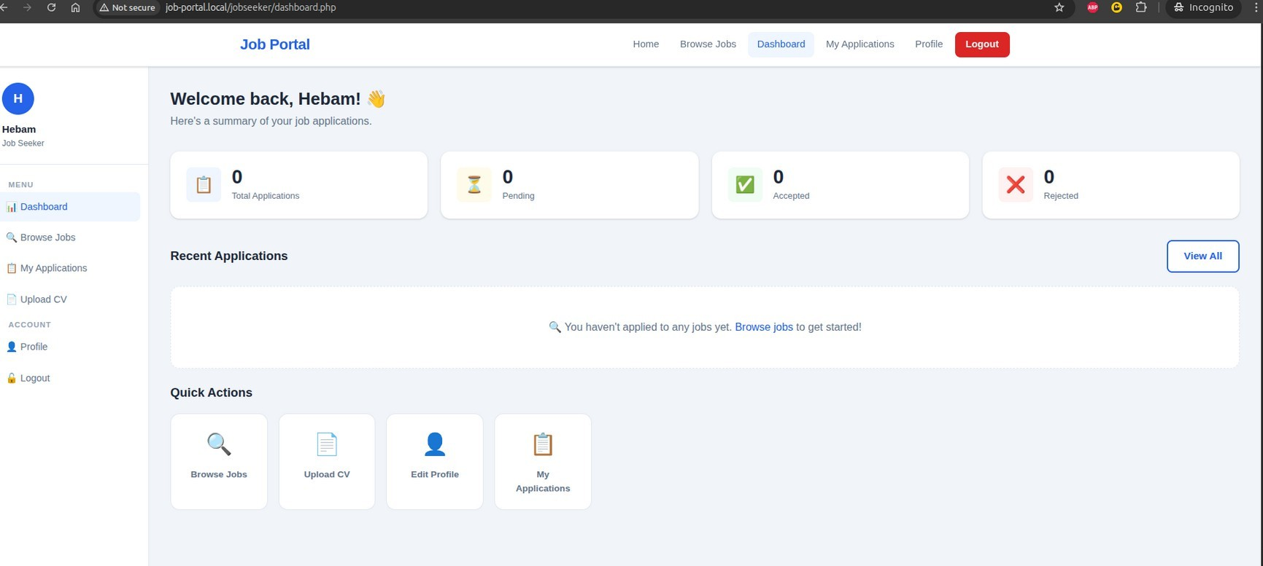
Figure 10:User Dashboard

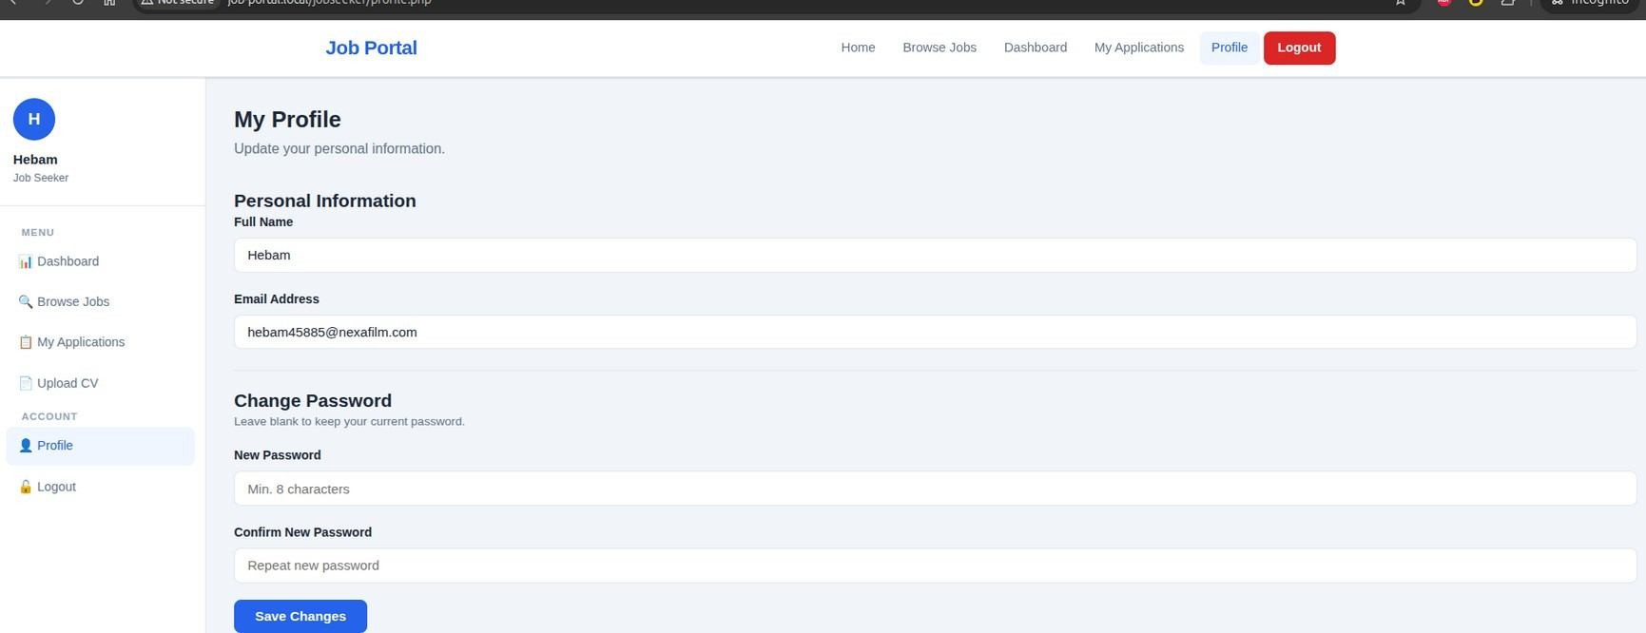
Figure 11:User Profile

- Sample Code

